The Domino Effect
The ocean is powerful. The moving water of ocean waves can cause massive destruction, which can instill fear in anyone. How are ocean waves able to cause so much destruction?
This lesson's investigation will examine the role of waves in transferring energy.

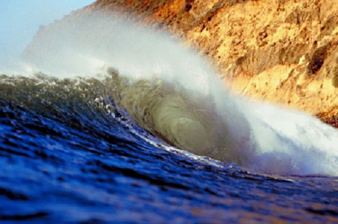

Waves Review
To better understand how ocean waves work on the particle level, you need to have a good understanding of waves. Take a minute to review some key concepts.
Think about how the dominoes relate to water particles in the ocean.

Galleria

Longitudinal waves

Drummer drumming on a rock kit.
In longitudinal waves, the energy moves parallel, or in the same direction, as the wave. Sound is an example of a longitudinal wave.

Transverse waves

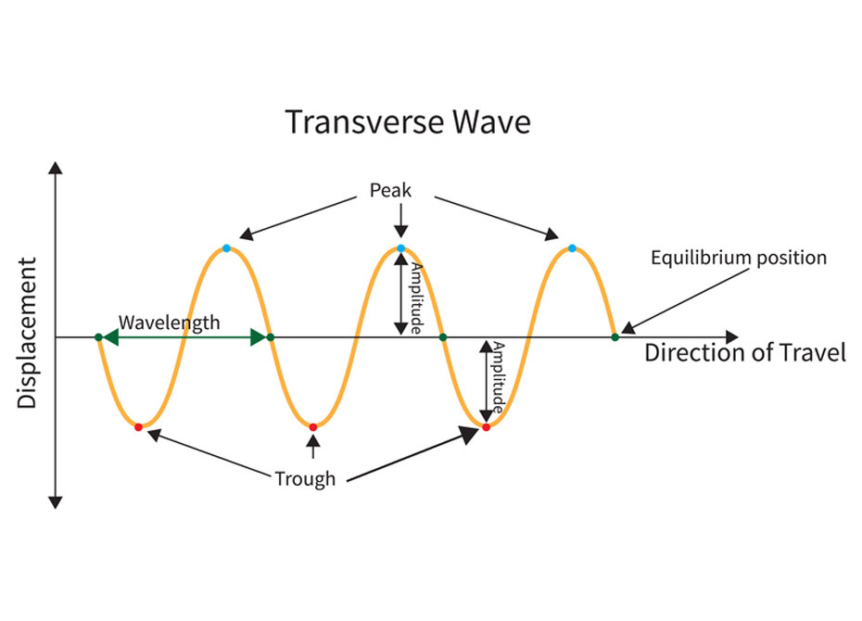
Diagram showing transverse and longitudinal wave forms.

In transverse waves, the energy moves perpendicular to the wave. If the wave is moving from left to right, the energy is moving up or down. Shaking a rope is an example of a transverse wave.

Surface waves
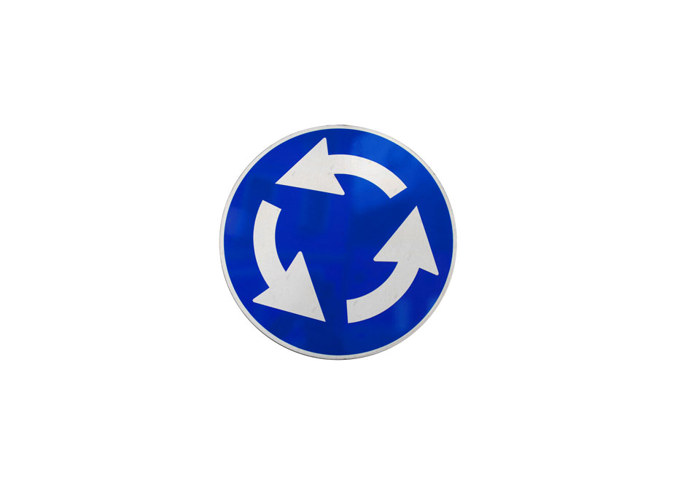
Representation of angular velocity.

Surface waves are a combination of longitudinal and transverse waves. The energy moves in two directions, both parallel and perpendicular to the wave. This can create a circular motion.

Wave speed
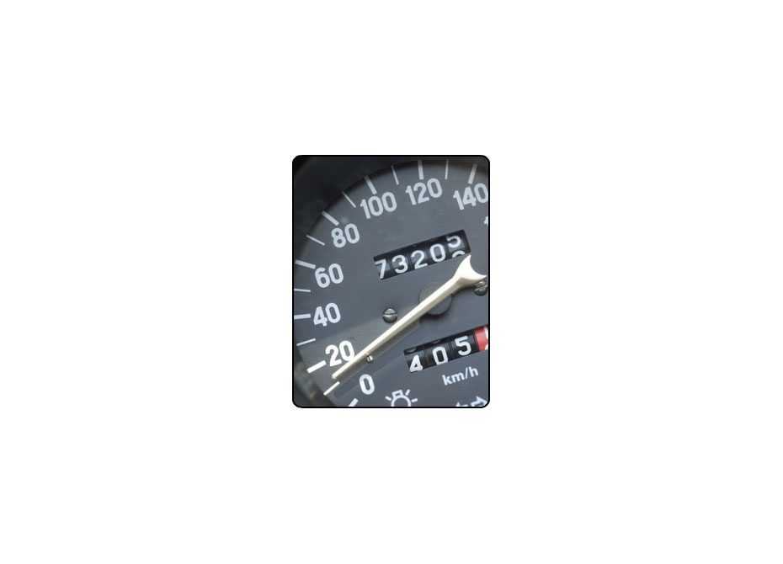
Speedometer.
The wave speed is how fast the wave moves or how many waves cycle through in a given time. The wave speed can be related to the amount of energy transferred.

Energy transfer
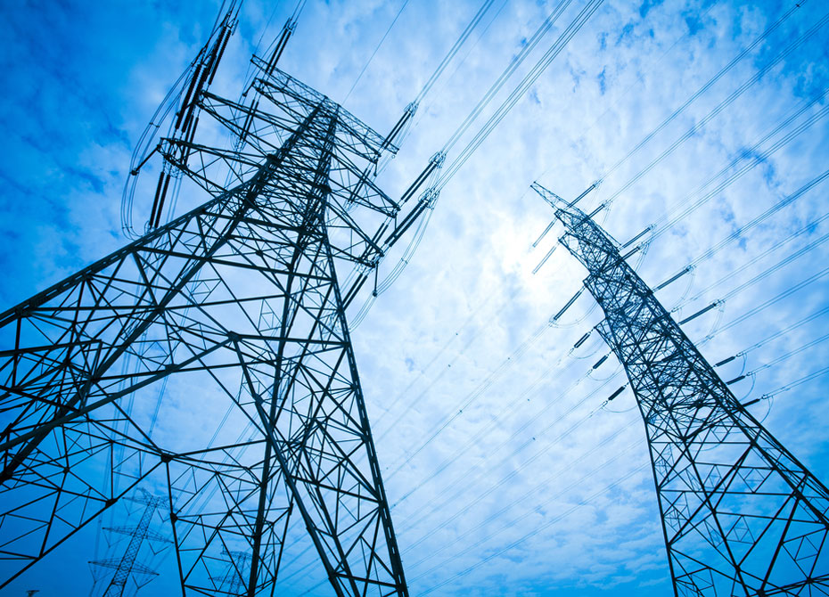
Electric power lines.
In mechanical waves, energy is transferred through a medium. The energy is moved from particle to particle away from the source.
Beware: Falling Dominoes
Now that you have reviewed some key concepts about waves, it's time to revisit the question of how waves actually go about transferring energy. Khianna tried using dominoes, similar to water particles, to simulate a wave.

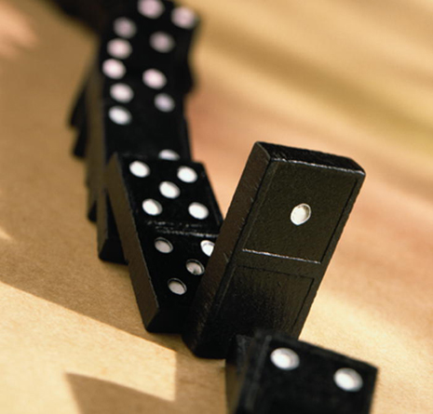

Study Club: Time for Dominoes to Fall

Screen 1
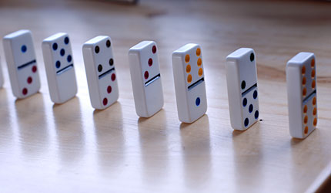

Domino Spacing – 4 cm

Image showing a line of dominoes each spaced 4 cm apart.

Khianna: First I gathered my materials which included 28 dominoes and a stopwatch. I placed the 28 dominoes standing up in a single line on a flat surface. The dominoes faced each other and were 4 cm apart. I then knocked over the first domino and started timing with my stopwatch. I stopped when the last domino hit the flat surface and recorded this time in my data table.

Screen 2
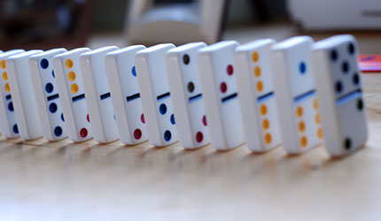
Domino Spacing – 2 cm

Image showing a line of dominoes each spaced 2 cm apart.

Khianna: Next, I placed the dominoes standing up in a single line 2 cm apart. I started the stopwatch when the first domino knocked into the second domino and stopped timing when the last domino hit the flat surface. I recorded this time in my data table.

Screen 3

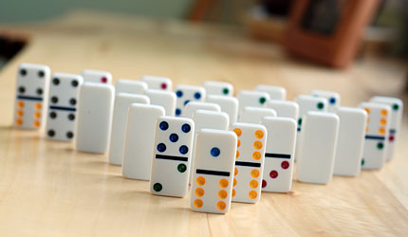

Pyramid Arrangement

Image showing dominoes stood in a pyramid formation

Khianna: For the last part of the investigation, I placed the dominoes standing up in a pyramid format. The dominoes were facing each other and were 4 cm apart. The domino in row one was placed so that it was in the center of the dominoes in row two. Row 1 had one domino, row 2 had two dominoes, row 3 had three dominoes, and so forth up to row 7. Again, I started the stopwatch when the first domino hit the second, and stopped the stopwatch when the last domino hit the flat surface. I recorded this time in my data table.

Creating a Data Table
It's common in experiments to gather data and record it on a data table. The data you put in the table should help provide evidence to answer your question. What makes a good data table? Here are some key features:
- Data – In an experiment you are changing something, a variable, and observing what happens. A data table should list what was changed and the observations that happened as a result. This represents one trial. Each trial typically composes one row of the data table. Add rows for multiple trials.
- Labels – Each column and/or row should be labeled. If units are needed, place the units in parenthesis next to the label or with the actual data/numbers.
- Table Title – Every data table should have a title so that someone else knows what your data represents.
- Other Information – Information about the experiment, such as temperature or other conditions, can be placed below the table.

Here is Khianna's data table.

Data Table – Time for Dominoes to Fall
Domino Spacing | Time (seconds)
4 cm apart line | 1.4
2 cm apart line | 0.8
Pyramid arrangement | 1.0

Assignment: Domino Investigation
Use the data chart to answer the questions in this assignment.

